# **Chapter 1**

**Introduction to Database Systems**

**Contents**

• Basic Definitions

• Typical DBMS Functionality

• Example of a Database (UNIVERSITY)

• Main Characteristics of the Database Approach • Database Users

• Data Models

• Schemas and Instances

• Three-schema Architecture and Data Independence

• Database Languages and Interfaces • The Database System Environment.

**Basic Definitions**

• **Database:**

– A collection of related data. • **Data:**

– Known facts that can be recorded and have an implicit meaning.

• **Mini-world:**

– Some part of the real world about which data is stored in a database. For example, student grades and transcripts at a university.

• **Database** **Management** **System** **(DBMS):**

– A software package/ system to facilitate the creation and maintenance of a computerized database.

• **Database** **System:**

– The DBMS software together with the data itself. Sometimes, the applications are also included.

**Problems with traditional approach**

• Inconsistency

• Redundancy

• Loss of flexibility

• Multiple files

• Update Problem

**Types of Databases and Database Applications**

• Traditional Applications:

– Numeric and Textual Databases

• More Recent Applications:

– Multimedia Databases

– Geographic Information Systems (GIS) – Data Warehouses

– Real-time and Active Databases – Many other applications

**Typical DBMS Functionality**

• *Define* a particular database in terms of its data types, structures, and constraints

• *Construct* or Load the initial database contents on a secondary storage medium

• *Manipulating* the database:

– Retrieval: Querying, generating reports

– Modification: Insertions, deletions and updates to its content – Accessing the database through Web applications

• *Processing* and *Sharing* by a set of concurrent users and application programs – yet, keeping all data valid and consistent

• Other features:

– Protection or Security measures to prevent unauthorized access

– Presentation and Visualization of data

– Maintaining the database and associated programs over the lifetime of the database application

• Called database, software, and system maintenance

**Simplified database system environment**

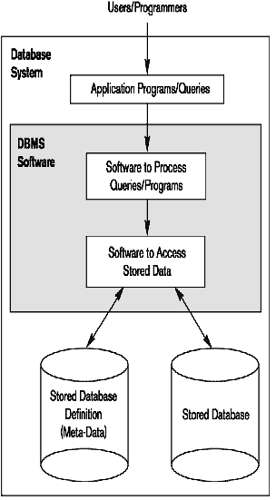

**Example of a Database (with a Conceptual Data Model)**

• **Mini-world** **for** **the** **example:**

– Part of a UNIVERSITY environment.

• **Some** **mini-world** ***entities*:**

– STUDENTs – COURSEs

– SECTIONs (of COURSEs)

– (academic) DEPARTMENTs

– INSTRUCTORs

• **Some** **mini-world** ***relationships*:**

– SECTIONs *are* *of* *specific* COURSEs

– STUDENTs belong to SECTIONs

– COURSEs *have* *prerequisite* COURSEs

– INSTRUCTORs *teach* SECTIONs

– COURSEs *are* *offered* *by* DEPARTMENTs

– STUDENTs *major* *in* DEPARTMENTs

**Main Characteristics of the Database Approach**

• **Self-describing** **nature** **of** **a** **database** **system:**

– A DBMS **catalog** stores the description of a particular database (e.g. data structures, types, and constraints)

– The description is called **meta-data**. This allows the DBMS software to work with different database applications such as University DB, Banking DB or Company DB.

• **Insulation** **between** **programs** **and** **data:** – Called **program-data** **independence**.

– Allows changing data structures and storage organization without having to change the DBMS access programs.

• **Data** **Abstraction:**

– The characteristic that allows program-data independence and program-operation independence

• Program-operation independence

– User application programs can operate on the data by invoking operations through their names and arguments, regardless of how the operations are implemented

– A **data** **model** is used to hide storage details and present the users with a conceptual view of the database.

– Relational model hides how the data is stored and how the operations are implemented. DB is represented in terms of entities, attributes and relationships among entities that is understood by most users.

– Programs refer to the data model constructs rather than data storage details

• **Support** **of** **multiple** **views** **of** **the** **data:**

– Each user may see a different view of the database, which describes **only** the data of interest to that user.

– A DBMS must enforce following transaction properties • Isolation

– Each transaction appears to execute in isolation from other transactions.

• Atomicity

– Either all the database operations in a transaction are executed or none are.

– *Concurrency* *control* within the DBMS guarantees that each **transaction** is correctly executed or aborted

– *Recovery* subsystem ensures each completed transaction has its effect permanently recorded in the database

– **OLTP** (Online Transaction Processing) is a major part of database applications. This allows hundreds of concurrent transactions to execute per second.

**Database Users**

• **Users may be divided into**

– Those who actually use and control the database content, and those who design, develop and maintain database applications (called “Actors on the Scene”), and

– Those who design and develop the DBMS software and related tools, and the computer systems operators (called “Workers Behind the Scene”).

• **Actors on the scene**

– **Database** **Administrators:**

• Responsible for authorizing access to the database, for coordinating and monitoring its use, acquiring software and hardware resources, controlling its use and monitoring efficiency of operations.

– **Database** **Designers:**

• Responsible to define the content, the structure, the constraints, and functions or transactions against the database. They must communicate with the end-users and understand their needs.

– **System** **Analysts** **and** **Application** **Programmers** **(Software** **Engineers)**

• Familiar with the full range of capabilities provided by the DBMS to accomplish their tasks

14

* **Categories of End-users**

– **End-users:** They use the data for queries, reports and some of them update the database content. End-users can be categorized into:

• **Casual**: access database occasionally when needed

• **Naïve** or Parametric: they make up a large section of the end-user population.

– They use previously well-defined functions in the form of “canned transactions” against the database.

– Examples are bank-tellers or reservation clerks who do this activity for an entire shift of operations.

• **Sophisticated:**

– These include business analysts, scientists, engineers, others thoroughly familiar with the system capabilities.

– Many use tools in the form of software packages that work closely with the stored database. – • **Stand-alone:**

– Mostly maintain personal databases using ready-to-use packaged applications. – An example is a tax program user that creates its own internal database.

– Another example is a user that maintains an address book

**Workers behind the Scene**

• DBMS System Designers and Implementers

– Design and implement the DBMS modules and interfaces as a software package

– Tool Developers

• Design and implement tools – the software packages that facilitate database modeling and design, database system design, and improved performance

– Operators and Maintenance Personnel

• Responsible for the actual running and maintenance of the hardware and software environment for the database system

**Data Models**

• **Data** **Abstraction**

– Suppression of details of data organization and storage and the highlighting of the essential features for an improved understanding of data

• **Data** **Model:**

– A collection of concepts to describe the ***structure*** of a database, the ***operations*** for manipulating these structures, and certain ***constraints*** that the database should obey.

– It provides necessary means to achieve data abstraction •

• **Data** **Model** **Structure** **and** **Constraints:**

– Constructs are used to define the database structure

– Constructs typically include ***elements*** (and their ***data*** ***types***) as well as groups of elements (e.g. ***entity,*** ***record,*** ***table***), and ***relationships*** among such groups

– Constraints specify some restrictions on valid data; these constraints must be enforced at all time.

• **Data** **Model** **Operations:**

– These operations are used for specifying database *retrievals* and *updates* by referring to the constructs of the data model.

– Operations on the data model may include ***basic*** ***model*** ***operations*** (e.g. generic insert, delete, update) and ***user-defined*** ***operations*** (e.g. compute_student_gpa, update_inventory)

**Categories of Data Models**

• **Conceptual** **(high-level,** **semantic)** **data** **models:**

– Provide concepts that are close to the way many users perceive data.

• (Also called ***entity-based*** or ***object-based*** data models.) • **Physical** **(low-level,** **internal)** **data** **models:**

– Provide concepts that describe details of how data is stored in the computer. These are usually specified in an ad-hoc manner through DBMS design and administration manuals

• **Implementation** **(representational)** **data** **models:**

– Provide concepts that fall between the above two, used by many commercial DBMS implementations (e.g. relational data models used in many commercial systems).

**Database Schema**

• Database Schema

– The ***description*** of a database.

– Includes descriptions of the database structure, data types, and the constraints on the database.

• Schema Diagram

– An ***illustrative*** display of (most aspects of) a database schema.

• Schema Construct

– A ***component*** of the schema or an object within the schema, e.g., STUDENT, COURSE.

**Example of a Database Schema**

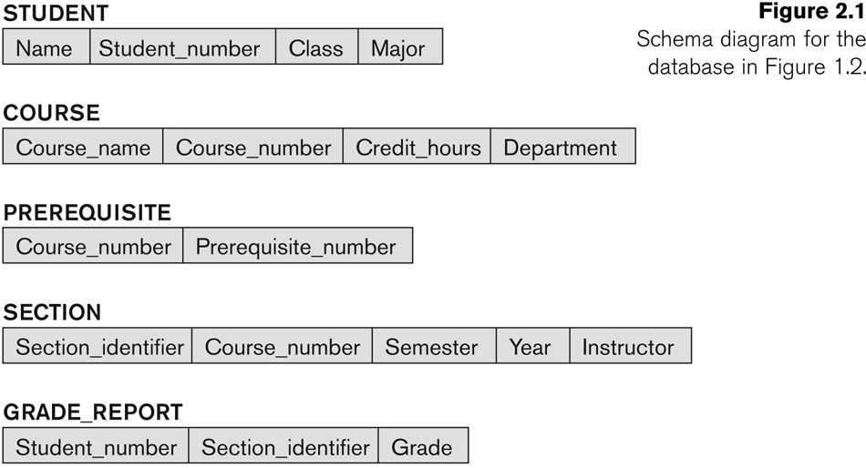

**Database State**

• Database State

– The actual data stored in a database at a ***particular*** ***moment*** ***in*** ***time***. This includes the collection of all the data in the database.

– Also called database instance (or occurrence or snapshot).

• The term *instance* is also applied to individual database components, e.g. *record* *instance,* *table* *instance,* *entity* *instance*

• Refers to the ***content*** of a database at a moment in time. • Initial Database State

– Refers to the database state when it is initially loaded into the system.

• Valid State

– A state that satisfies the structure and constraints of the database.

**DB Schema v/s DB State**

• Distinction

– The ***database*** ***schema*** changes very infrequently.

– The ***database*** ***state*** changes every time the database is updated.

• **Schema** is also called **intension**.

• **State** is also called **extension**.

**Three-Schema Architecture**

• Proposed to support DBMS characteristics of: – **Program-data** **independence.**

– Support of **multiple** **views** of the data.

• Its goal is to separate the user applications and the physical database.

• Not explicitly used in commercial DBMS products, but has been useful in explaining database system organization

• Defines DBMS schemas at ***three*** levels:

– **Internal** **schema** at the internal level to describe physical storage structures and access paths (e.g indexes).

• Typically uses a **physical** data model.

– **Conceptual** **schema** at the conceptual level to describe the structure and constraints for the whole database for a community of users. It describes entities, data types, relationships, user operations and constraints.

• Uses a **conceptual** or an **implementation** data model.

– **External** **schemas** at the external level (or view level) to describe the various user views.

• Usually uses the same data model as the conceptual schema.

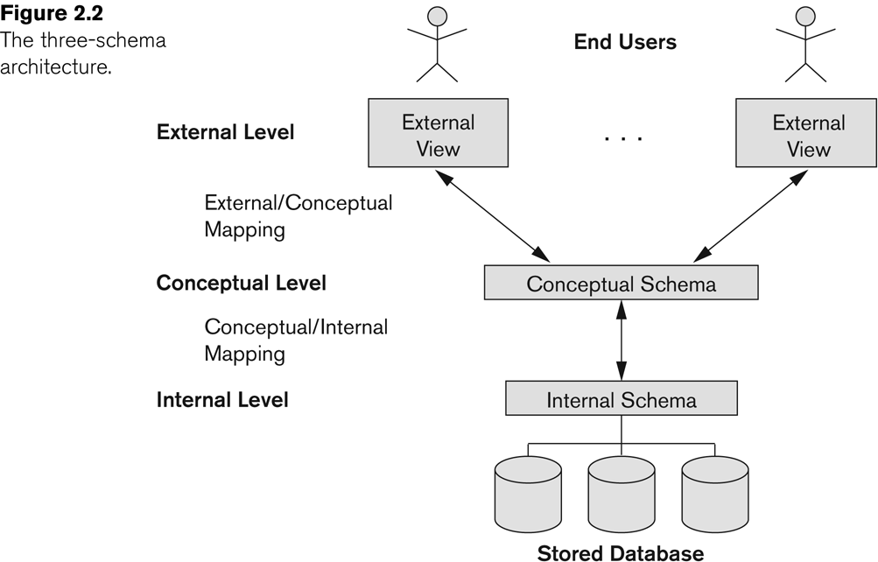

**Data Independence**

• **Logical** **Data** **Independence:**

– The capacity to change the conceptual schema without having to change the external schemas and their associated application programs.

• **Physical** **Data** **Independence:**

– The capacity to change the internal schema without having to change the conceptual schema.

– For example, the internal schema may be changed when certain file structures are reorganized or new indexes are created to improve database performance

• When a schema at a lower level is changed, only the **mappings** between this schema and higher-level schemas need to be changed in a DBMS that fully supports data independence.

• The higher-level schemas themselves are **unchanged**.

– Hence, the application programs need not be changed since they refer to the external schemas.

**DBMS Languages**

• Data Definition Language (DDL)

• Data Manipulation Language (DML)

– High-Level or Non-procedural Languages: These include the relational language SQL

• May be used in a standalone way or may be embedded in a programming language

– Low Level or Procedural Languages:

• These must be embedded in a programming language

• **Data** **Definition** **Language** **(DDL):**

– Used by the DBA and database designers to specify the conceptual schema of a database.

– In many DBMSs, the DDL is also used to define internal and external schemas (views).

– In some DBMSs, separate **storage** **definition** **language** **(SDL)** and **view** **definition** **language** **(VDL)** are used to define internal and external schemas.

• SDL is typically realized via DBMS commands provided to the DBA and database designers

• **Data** **Manipulation** **Language** **(DML):**

– Used to specify database retrievals and updates

– DML commands (data sublanguage) can be *embedded* in a general-purpose programming language (host language), such as COBOL, C, C++, or Java.

• A library of functions can also be provided to access the DBMS from a programming language

– Alternatively, stand-alone DML commands can be applied directly (called a *query* *language*).

**Types of DML**

• **High Level or Non-procedural Language:**

– For example, the SQL relational language

– Are “set”-oriented and specify what data to retrieve rather than how to retrieve it. Many records can be retrieved in one DML statement

– Also called **declarative** languages.

• **Low** **Level** **or** **Procedural** **Language:**

– Retrieve data one record-at-a-time;

– Constructs such as looping are needed to retrieve multiple records, along with positioning pointers.

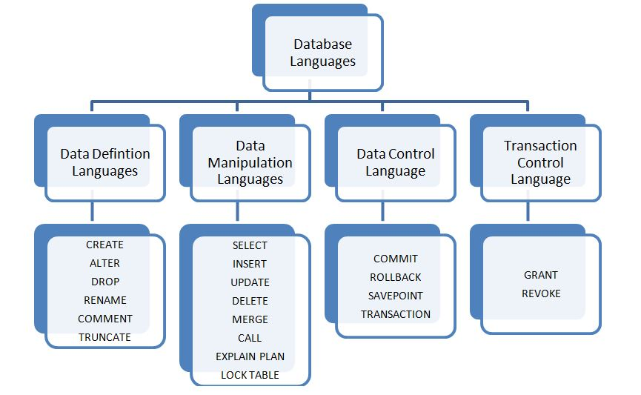

**DBMS Interfaces**

* Stand-alone query language interfaces

Example: Entering SQL queries at the DBMS interactive SQL interface (e.g. SQL*Plus in ORACLE)

When a DML embedded in general purpose programming model, that language is called host language and DML is called data sublanguage

* Programmer interfaces for embedding DML in programming languages
* User-friendly interfaces
* Menu-based, forms-based, graphics-based, etc.

**DBMS Programming Language Interfaces**

* Programmer interfaces for embedding DML in a programming languages:
  + Embedded Approach: e.g embedded SQL (for C, C++, etc.), SQLJ (for Java)
  + Procedure Call Approach: e.g. JDBC for Java, ODBC for other programming languages
  + Database Programming Language Approach: e.g. ORACLE has PL/SQL, a programming language based on SQL; language incorporates SQL and its data types as integral components

**User-Friendly DBMS Interfaces**

* + Menu-based, popular for browsing on the web
  + Forms-based, designed for naïve users
  + Graphics-based
  + (Point and Click, Drag and Drop, etc.)
  + Natural language: requests in written English
  + Combinations of the above:
  + For example, both menus and forms used extensively in Web database interfaces

**Other DBMS Interfaces**

* + Speech as Input and Output
  + Web Browser as an interface
  + Parametric interfaces, e.g., bank tellers using function keys.
  + Interfaces for the DBA:
    - Creating user accounts, granting authorizations
    - Setting system parameters
    - Changing schemas or access paths

**Typical DBMS Component Modules**

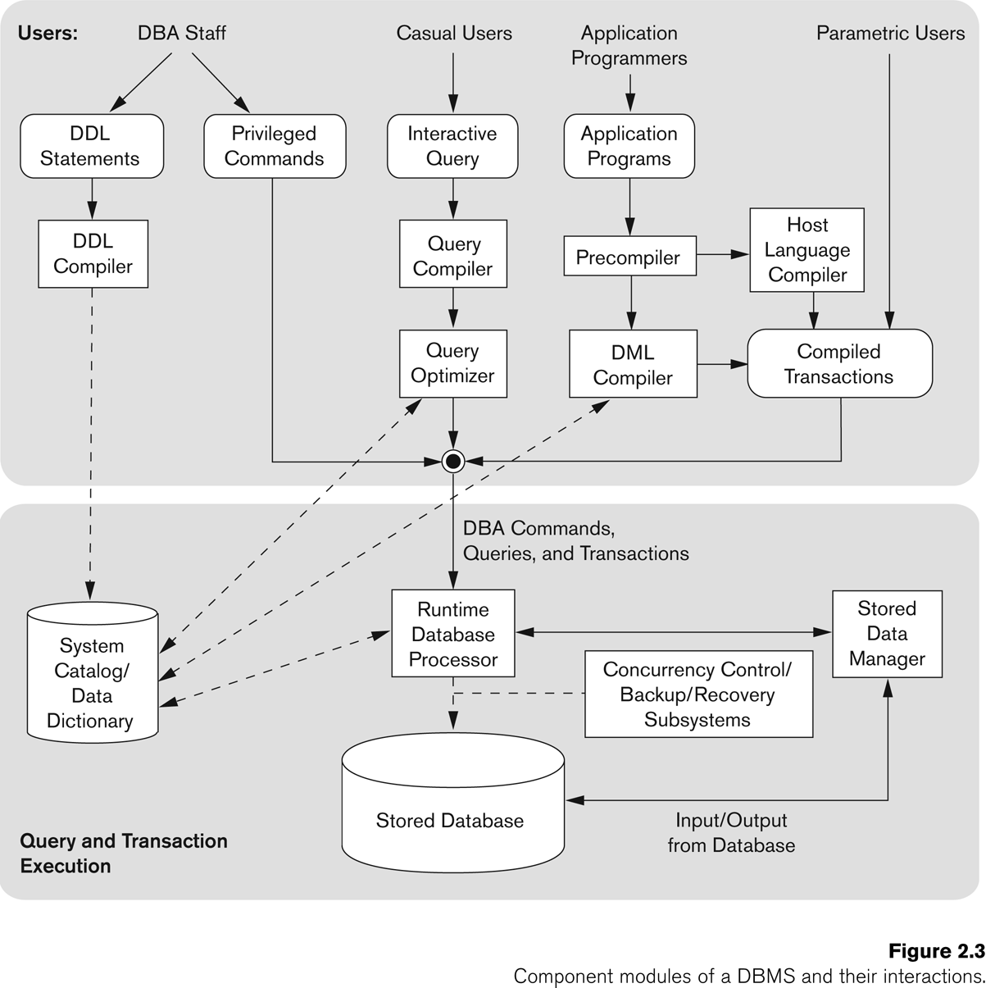

34